Global Workforce Reduction Analysis (2020–2026)

Domain

Global Workforce Reduction Analysis (2020–2026)

Tools & Technologies Used
Excel | Python | Tableau

Techniques Applied
Data Cleaning & Preprocessing
• Exploratory Data Analysis (EDA)
• Time Series Analysis (Yearly & Monthly Trends)
• Pareto Analysis (80/20 Rule for company impact)
• Geographic Analysis (Country & City-level insights)
• KPI Design & Dashboard Storytelling
• Data Visualization Best Practices
• LOD Expressions (Level of Detail) for accurate aggregation

Project Difficulty Level
Intermediate

Dataset Availability
The dataset used in this project consists of financial and sales data used for analysis and dashboard development.
https://github.com/pranjalgupta4482-ui/Global-workforce-reduction-analysis/blob/main/global_ai_tech_layoffs_2020_2026.csv

Dataset Information
The dataset used in this project contains detailed information on global workforce reductions across multiple companies, industries, and regions over the period from 2020 to 2026. It provides a comprehensive view of layoff trends, enabling analysis at both macro and micro levels.
The dataset includes the following key attributes:
• Company – Name of the organization where layoffs occurred
• Industry – Sector to which the company belongs (e.g., E-commerce, IT Services, Fintech)
• Number of Employees Laid Off – Total number of employees affected
• Percentage of Workforce Affected – Proportion of employees laid off relative to company size
• Date Announced – Date on which layoffs were officially announced
• Year and Month – Derived fields used for time-based analysis
• Headquarters Country – Country where the company is based
• Headquarters City – City location of the company
• Stage / Funding (if available) – Company growth stage or funding status
• Primary Reason for Layoffs – Key reason behind workforce reduction (e.g., cost cutting, restructuring)
The dataset was sourced from publicly available records and includes multiple entries for companies over different time periods, allowing for detailed trend and comparative analysis.
To ensure accuracy and usability, the dataset was cleaned and preprocessed before analysis, including handling missing values, standardizing formats, and creating derived features.

Tools & Techniques Used
The project was developed using a combination of data processing, analysis, and visualization tools to ensure an end-to-end analytical workflow.
Tools Used:
• Microsoft Excel
Used for initial data inspection, basic cleaning, and validation of the dataset.
• Python (Pandas, NumPy, Jupyter Notebook)
Used for data cleaning, transformation, and exploratory data analysis (EDA), including handling missing values and feature engineering.
• Tableau Desktop
Used for building interactive dashboards, KPI visualization, trend analysis, and advanced visual storytelling.
Techniques Applied:
• Data Cleaning & Preprocessing
• Exploratory Data Analysis (EDA)
• Time Series Analysis (Yearly & Monthly Trends)
• Pareto Analysis (80/20 Rule for company impact)
• Geographic Analysis (Country & City-level insights)
• KPI Design & Dashboard Storytelling
• Data Visualization Best Practices
• LOD Expressions (Level of Detail) for accurate aggregation
This combination of tools and techniques enabled a comprehensive analysis of global workforce reduction trends and ensured accurate, insightful, and visually compelling results.

Problem Statement
In recent years, global workforce reductions have become increasingly prevalent across industries, especially in the post-pandemic period. Companies that expanded rapidly during growth phases are now undergoing restructuring, leading to large-scale layoffs. However, these workforce reductions are not uniformly distributed and vary significantly across industries, companies, and geographic regions.
The challenge lies in understanding the underlying patterns and key drivers of layoffs. Without proper analysis, it is difficult to identify which sectors are most affected, which companies contribute the most to layoffs, and how workforce reductions evolve over time.
This project aims to address these challenges by analysing global layoff data to uncover meaningful insights. It focuses on identifying trends, measuring impact, and highlighting concentration patterns across companies and regions. The goal is to transform raw data into actionable insights through effective data cleaning, analysis, and visualization techniques.

Objectives
The primary objective of this project is to analyse global workforce reduction data and extract meaningful insights related to trends, distribution, and impact of layoffs across industries and regions.
The specific objectives of the project are:
• To analyse yearly and monthly trends in workforce reductions to identify peak periods and seasonal patterns
• To examine industry-wise layoffs and determine which sectors are most affected
• To identify top companies contributing to layoffs using Pareto analysis
• To study the geographic distribution of layoffs across countries and major cities
• To evaluate the impact of layoffs using workforce percentage metrics
• To build an interactive and user-friendly dashboard for effective data visualization and decision-making
• To provide actionable insights that help understand the reasons and patterns behind global workforce reductions

Methodology
The project follows a structured data analytics workflow, starting from data collection to final visualization and insight generation. The methodology is divided into the following key stages:
- Data Collection
The dataset was obtained from publicly available sources containing global workforce reduction information across companies, industries, and regions.
- Data Understanding and Validation
The dataset was reviewed using Excel and Python to understand its structure, variables, and consistency. This included:
• Verifying data formats and data types
• Checking for missing or inconsistent values
• Validating key fields such as dates, company names, and numerical values
- Exploratory Data Analysis (EDA)
EDA was performed using Python (Pandas) to understand data distribution and identify trends. Key analyses included:
• Year-wise and month-wise trends
• Industry-wise layoffs
• Company-level contributions
• Geographic distribution of layoffs
- Data Transformation
The cleaned dataset was structured for visualization by aggregating relevant metrics such as total layoffs, average workforce impact, and company-wise contributions.
- Dashboard Development
Tableau was used to build interactive dashboards, including:
• KPI cards for summary metrics
• Time-series charts for trend analysis
• Pareto charts for company-level insights
• Maps for geographic visualization
• Filters and navigation for interactivity
- Insight Generation
Key insights were derived by analysing patterns across time, industry, geography, and company-level data. These insights were integrated into the dashboard for better storytelling and decision-making.

Tableau Dashboard Description
The project includes two interactive dashboards built using Tableau to provide both high-level insights and detailed analysis of global workforce reductions.
- Overview Dashboard
The Overview Dashboard presents a summary of key metrics and trends related to workforce reduction from 2020 to 2026. It is designed to provide a quick understanding of the overall situation.
Key components include:
• KPI Cards – Display total layoffs, average workforce impact percentage, and number of companies affected
• Yearly Trend Analysis – Shows the trend of layoffs over the years, highlighting peak periods such as 2023
• Monthly Trend Analysis – Identifies seasonal patterns and fluctuations in workforce reductions
• Pareto Analysis – Highlights top companies contributing to the majority of layoffs, demonstrating the 80/20 principle
• Global Map – Visualizes the geographic distribution of layoffs across countries
• Filters Panel – Allows users to filter data by year, company, country, and month for dynamic exploration
This dashboard provides a comprehensive overview and enables users to quickly identify key patterns and trends.
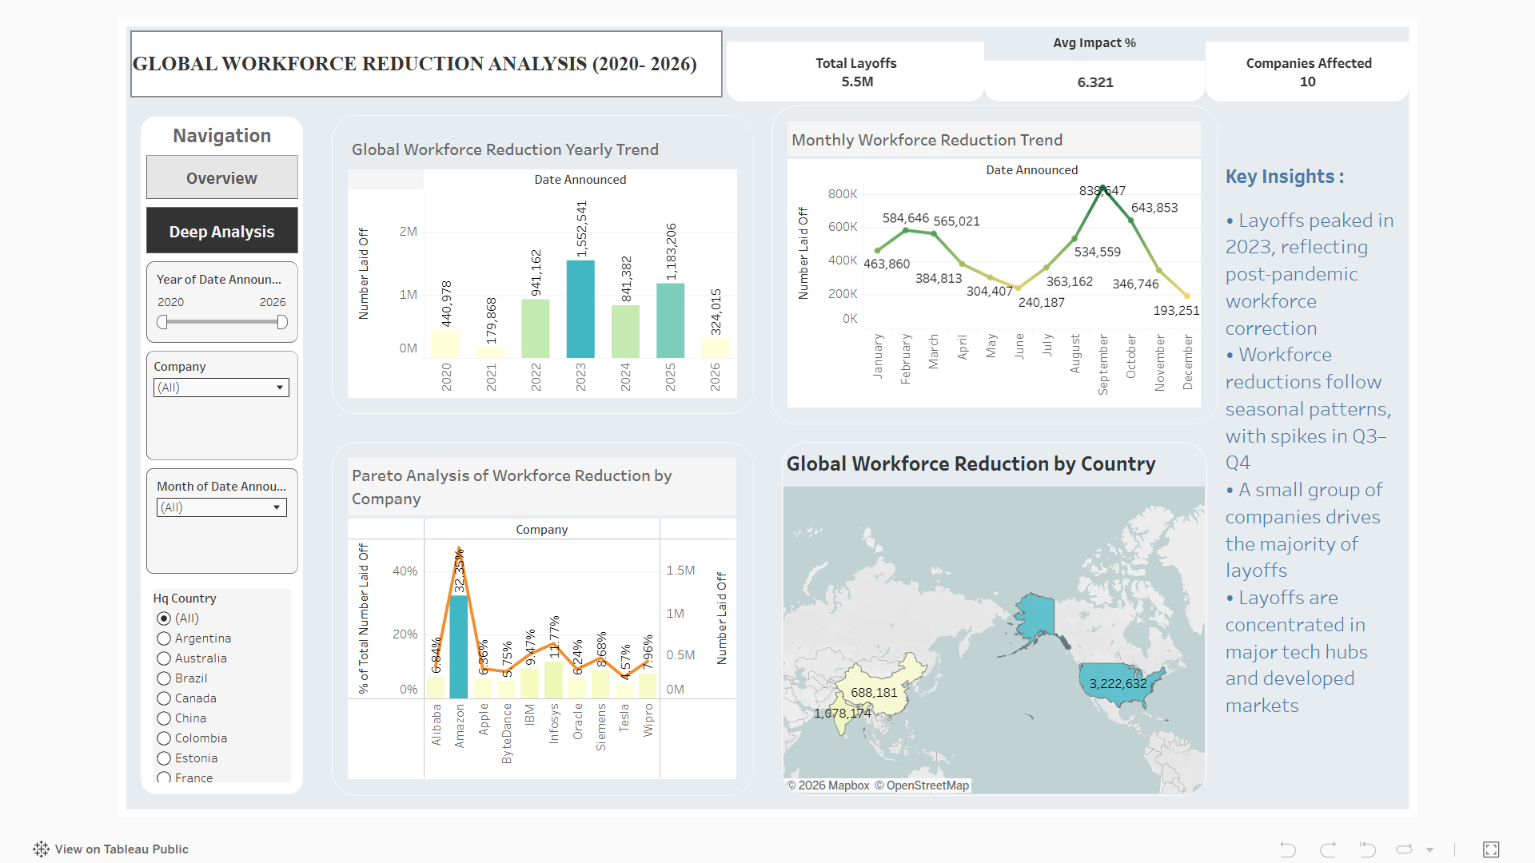

- Deep Analysis Dashboard
The Deep Analysis Dashboard focuses on detailed, granular insights into workforce reduction patterns across companies and cities.
Key components include:
• Treemap (Company & Industry) – Displays workforce reduction by company and industry, highlighting dominant contributors
• City Distribution (Pie Chart) – Shows the proportion of layoffs across major cities, identifying key layoff hubs
• Volume vs Impact Analysis – A dual-axis chart comparing number of layoffs with workforce impact percentage to understand strategic differences
• KPI Cards – Reinforce key metrics for quick reference
• Filters Panel – Enables detailed analysis by year, company, city, and time period
This dashboard allows users to drill down into specific areas and understand how layoffs are distributed at a more detailed level.
Overall, the dashboards are designed to combine visual storytelling with interactivity, enabling users to explore data effectively and derive meaningful insights.
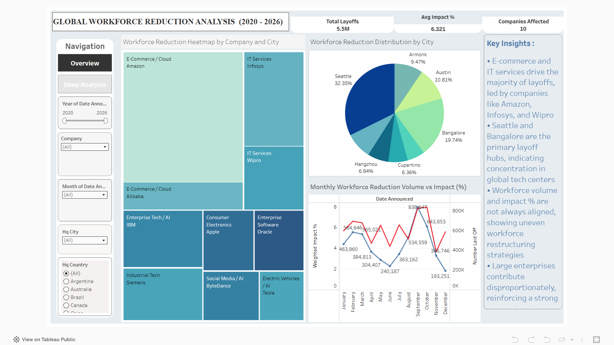

Key Insights
The analysis of global workforce reduction data from 2020 to 2026 reveals several important trends and patterns across time, industries, companies, and geographies.
- Peak in Workforce Reductions (2023)
The data shows a significant spike in layoffs during 2023, marking the highest workforce reduction across the observed period. This trend reflects post-pandemic corrections, where companies adjusted their workforce after aggressive hiring during 2020–2022.
- Strong Seasonal Patterns in Layoffs
Monthly analysis indicates that layoffs are not evenly distributed throughout the year. There is a noticeable increase in workforce reductions during mid-year and year-end periods (Q3–Q4), likely aligned with budget reviews, performance cycles, and strategic restructuring decisions.
- Industry Concentration of Layoffs
The majority of layoffs are concentrated in a few key sectors, particularly E-commerce, IT Services, and Enterprise Software. These industries experienced rapid expansion during the pandemic and later underwent significant restructuring.
- Pareto Distribution Among Companies
The analysis highlights a strong Pareto pattern, where a small group of companies contributes to a large proportion of total layoffs. Major organizations such as Amazon, Infosys, and other large enterprises dominate workforce reductions, indicating that layoffs are driven more by large-scale corporate decisions rather than widespread small-company impact.
- Geographic Concentration in Tech Hubs
Layoffs are heavily concentrated in major global technology hubs, including Seattle, Bangalore, and Austin. These regions host leading technology companies, making them more susceptible to large-scale workforce adjustments.
- Dominance of Developed Markets
The global map analysis shows that developed markets, particularly the United States, account for a significant share of total layoffs. This reflects the concentration of large technology firms and mature industries in these regions.
- Misalignment Between Volume and Impact Percentage
The comparison between the number of layoffs and workforce impact percentage reveals that higher layoff volumes do not always correspond to higher impact percentages. This indicates that some companies implement targeted layoffs affecting a smaller portion of their workforce, while others undergo broader restructuring.
Overall, the insights suggest that global workforce reductions are strategic, concentrated, and influenced by industry dynamics, geographic factors, and company-level decisions rather than random or uniform trends.

Business Recommendations
Based on the analysis of global workforce reduction trends, the following recommendations can help organizations make more informed and strategic workforce decisions:
• Adopt Strategic Workforce Planning
Companies should align hiring with long-term business goals to avoid over-hiring during growth phases and reduce the need for large-scale layoffs later.
• Focus on Skill Development and Reskilling
Investing in employee upskilling can reduce layoffs caused by skill mismatches and support internal mobility during organizational changes.
• Use Data-Driven Decision Making
Organizations should leverage data analytics to monitor workforce trends, predict risks, and make proactive decisions rather than reactive layoffs.
• Optimize Costs Without Over-Reliance on Layoffs
Instead of immediate workforce reduction, companies can explore alternatives such as cost restructuring, process optimization, and operational efficiency improvements.
• Diversify Business and Market Exposure
Reducing dependency on a single market or product can help organizations remain stable during economic downturns and minimize workforce impact.
• Improve Workforce Distribution Across Regions
Since layoffs are concentrated in major tech hubs, companies should consider geographic diversification to reduce regional risk concentration.
• Enhance Employee Communication and Transparency
Clear communication during organizational changes helps maintain trust and reduces uncertainty among employees.

Conclusion
The Global Workforce Reduction Analysis (2020–2026) highlights that layoffs are driven by a combination of macroeconomic pressures and company-level decisions. The peak observed in 2023 reflects post-pandemic corrections, cost optimization efforts, and shifts in business strategy.
Major contributors to layoffs include over-hiring during high-growth periods, declining revenues, automation and digital transformation, mergers and restructuring, and changing market demand. At an individual level, factors such as performance management, role redundancy, skill mismatch, and remote work realignment also influence workforce reductions.
The analysis further shows that layoffs are concentrated among large enterprises and major tech hubs, rather than being evenly distributed. Overall, the project demonstrates how data analytics can uncover both structural and human factors behind workforce changes, enabling a more holistic understanding of global layoffs.

Tableau Dashboard Link
The interactive dashboards created for this project can be accessed using the link below:
🔗 Overview & Deep Analysis Dashboard:
https://public.tableau.com/app/profile/pranjal.gupta4377/viz/globalworkforcereduction2020-2026/overview
The dashboards provide an interactive experience, allowing users to explore workforce reduction trends through filters, navigation, and dynamic visualizations.

